Report 24th September 2025
Agenda Number 22/5 – Kings Dell
Bench Examples
Company A
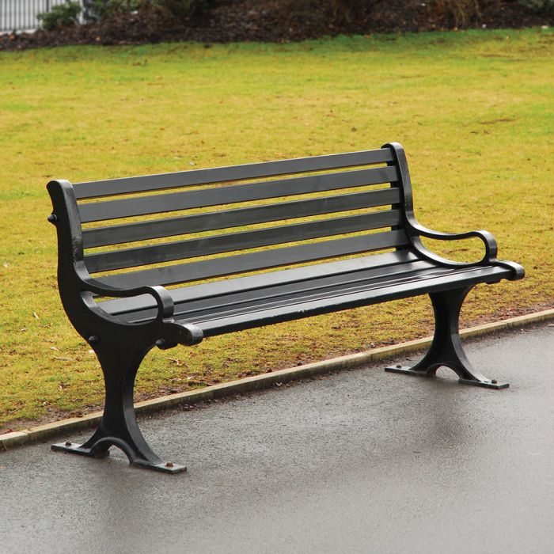
Blackburn Anti Vandel Seat
Recycled Plastic £857 including fixings

Company B
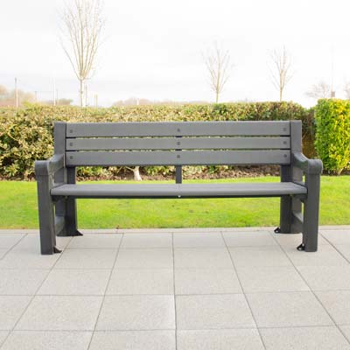
Bowman Seat recycled plastic
£978.67
Including fixings and delivery

Company C

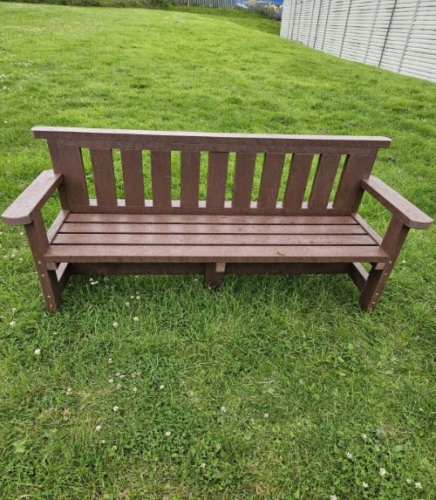
Consett Seat
Recycled Plastic £468.60
Including fixings and delivery

(The cost for two benches would be £937.20)

