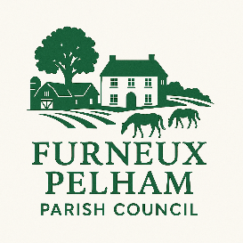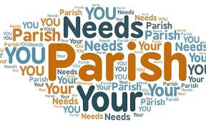

VACANCY FOR PARISH COUNCILLOR
FURNEUX PELHAM

Furneux Pelham Parish Council has a Casual Vacancy and wish to recruit someone onto the council. Could this be you?
• Do you want to serve your community?
• Do you have time or expertise which could benefit your community?
• Do you want to make a difference to all those around you?
• Are you concerned about your local area?
• Do you want to represent the views of local people?
If you would like to make a difference, and be involved in shaping the future of your local Community, why not step forward and apply to fulfil this role? Furneux Pelham Parish Council is looking for a new Parish Councillor - specifically someone who has local knowledge, history of the parish, and interest in the environment and is keen to work with the Team – if you are interested, would like more information or an application form, please contact the Clerk, Yvonne Merritt, on clerk@furneuxpelham-pc.gov.uk
Eligibility Criteria
• You are registered as a local government elector for the parish.
• You have occupied as owner or tenant any land or other premises in the parish during the whole of the 12 months before the day of appointment.
• Your main or only place of work during the 12 months prior to the day of appointment has been in the parish; or
• You have lived in the parish or within three miles of it during the whole of the 12 months before the day of appointment.
Closing date for completed applications to be with the Clerk no later than
13th March 2026

