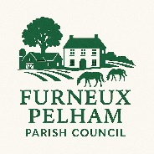

FURNEUX PELHAM PARISH COUNCIL
ANNUAL PARISH MEETING
AGENDA
To: Cllrs S Bratt, K Bayes, B Goodman, A Gravestock, H Smart,

You are hereby summoned to attend the Annual Parish Meeting of Furneux Pelham Parish Council which will be held on Wednesday 27th May 2025 7.30pm. Members of the public and press who wish to attend are invited to do so. There will be an opportunity for members of the public to speak at the end of the meeting.
Stephen Bratt

Chairman
Furneux Pelham Parish Council
13th May 2026

Associated documents can be found at www.furneuxpelham-pc.gov.uk

26/01 | Apologies for Absence  To receive and approve apologies for absence | Cllrs
26/02 | Notice covering the meeting | Cllrs
26/03 | To approve the minutes of the meeting dated 28th May 2025 | Cllrs
26/04 | Annual report – to receive the Annual reports from Councillors and the Clerk | Chair
26/05 | Open Forum

