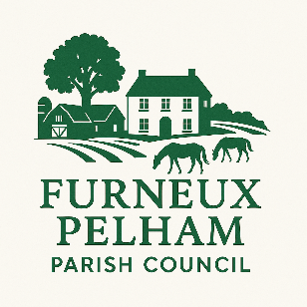

You are invited to attend the

COUNCILLOR FORUM

Learn about the Role of the

Parish Council and speak to

Councillors and the Clerk

Furneux Pelham Village Hall

25th November 2026

at 7.00pm

This will be followed by the
PARISH COUNCIL
MEETING
at 7.30pm

